A000-AFR-Egy-Ushabti-Plain Lappet wig with one band-Plinth back-10 rows of Hieroglyphs-Blue Faience-Late Period-570-526 BCE

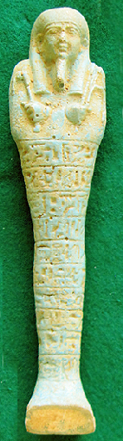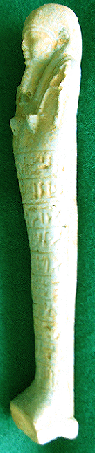

**Case no.: 2**

**Accession Number:**

**Formal Label:** Ushabti-Plain Lappet wig with one band-Plinth back-10 rows of Hieroglyphs-Blue Faience-Late Period-570-526 BCE

**Display Description:**

**This** Ushabti of the 27th dynasty of the Late Period has a Plain tripartite lappet wig with 2 bands, a plain plinth back-ten horizontal registers of hieroglyphs down the front and is glazed in blue faience. The hands protrude from a shroud to hold with the left a pick and with the right a hoe. The twisted rope for a basket extends frontally from the left hand up the left shoulder but the basket on the ushabti’s back is missing. The facial details are especially fine. The back is supported with a shallow dorsal pillar and the Ushabti stands on a trapezoidal base.

The fine workmanship on this Ushabti indicates the exceptional effort to confirm the owner’s identity and influence during the turbulent reign of Aryandes.

**LC Classification: DT 62**

**Date or Time Horizon:** Late Period, 570-526 BCE

**Geographical Area: Saqqara, Egypt**

**Map, GPS Coordinates:** 29.85000 31.21667; [29°52′16″N 31°12′59″E](https://tools.wmflabs.org/geohack/geohack.php?pagename=Saqqara&params=29_52_16_N_31_12_59_E_type:landmark)

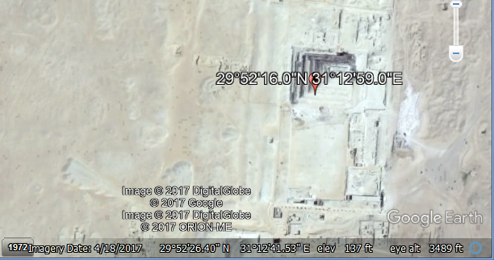

**Cultural Affiliation:** Late Period, Egypt, 27th Dynasty-525-334 BCE.

**Geographical Area: Saqqara, Egypt**

**Medium:** Blue Faience

**Dimensions:** H 1.789 in, 45.43 mm

**Weight: 2.78 oz, 83 gm**

**Condition: original**

**Provenance:** Stavros Nicolaides Alexandrou Papadiamandi 7020 CYPRUS, Larnaca Cyprus

**Discussion:**

When, in May 525 BCE, Cambyses II defeated Psamtik III of the 26th Dynasty at the battle of Pelusium in the eastern Nile delta, Cambyses was crowned Pharaoh of Egypt, which initiated the first period of Persian rule over Egypt (known as the 27th Dynasty). At this point, Egypt was united with Cyprus and Phoenicia to form the sixth satrapy of the Achaemenid Empire and Aryandes was proclaimed the local provincial governor or satrap of Egypt. In 522 BCE, Aryandes was overthrown due to a revolt against the Achaemenid rule led by a native Egyptian pharaoh, Petubastis III. The rebellion was personally quelled by the new king Darius I during his expedition to Egypt in 518 BCE, and Aryandes was reinstated (Ray 2006: 262-266).

**References:**

Ray, John D. 2006. "Egypt, 525–404 B.C.". In Boardman, John; Hammond, N.D.L.; Lewis, D.M.; Ostwald, M. *The Cambridge Ancient History* (2nd ed.), vol. IV – Persia, Greece and the Western Mediterranean c. 525 to 479 B.C. Cambridge: Cambridge University Press.